**LEBANESE AMERICAN UNIVERSITY**

**USAID – HIGHER EDUCATION SCHOLARSHIP PROGRAM**

**HES - Volunteering Program Verification Form**

This form is to be used to document volunteering hours. If a student volunteers for multiple organizations, a separate form must be used for each organization. **This form must be turned in by the 28th of each month, the latest.**

I certify that the scholar Rim Ali Al Sayyed completed a total of 5 hours of service at InnovaThrive.

The hours were completed hours as per the below:

Hours # 0 (date) _2/12 – 6/12_ (initials of supervisor) __A.K.___

Hours # 0 (date) _9/12 – 13/12_ (initials of supervisor) __A.K.___

Hours # 0 date) _16/12 – 20/12 (initials of supervisor) __A.K.___

Hours # 5 date) _23/12 - 27/12 (initials of supervisor) __A.K.___

Brief description of the activities the scholar performed or participated in:

I did a research about :  
  
Blockchain in Securing Digital Intellectual Property  
Definition: Using blockchain to safeguard intellectual property in digital media.  
Technologies:  
  
Decentralized ledgers to register and verify digital creations.  
Smart contracts for managing rights and royalties.  
Applications:  
Protecting artists’ digital work from piracy.  
Ensuring fair compensation for digital creators.  
Statistics: Blockchain reduces digital piracy by 50% in tested sectors.  
Advantages:  
Increased trust and transparency in digital media markets.  
Disadvantages:  
Scalability issues for large media companies.  
Challenges:  
Educating digital creators on blockchain technology.  
Future Research:  
Integrating AI with blockchain for automated intellectual property enforcement.  
  
Expanding blockchain solutions for non-digital intellectual property.

Written feedback about the scholar’s performance:

Rim Ali Al Sayyed’s research on blockchain in securing digital intellectual property reflected a high level of effort and understanding. Nevertheless, her volunteering form was submitted late. This lack of punctuality is unacceptable. Timely submission of all required documents is expected to avoid further issues.

Please rate the overall performance of the scholar at your organization:

|  |  |  |  |
| --- | --- | --- | --- |
|  | Mastery (5) | Proficient (3) | Emerging (1) |
| **Problem solver** | X |  |  |
| **Engaged & Committed** | X |  |  |
| **Open-minded & multicultural** | X |  |  |

Signature

& stamp

__________________________

_

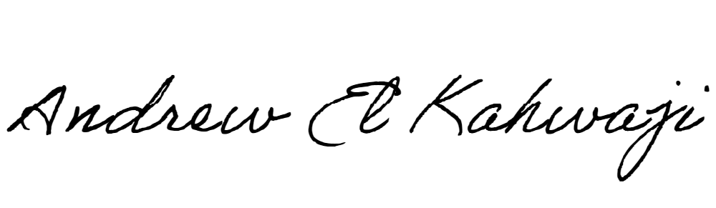

Printed Name _Andrew El Kahwaji_

Date __26/12/2024___

Email __andrew.lifesculptor.coo@gmail.com __

Phone __+961 71 914 378__